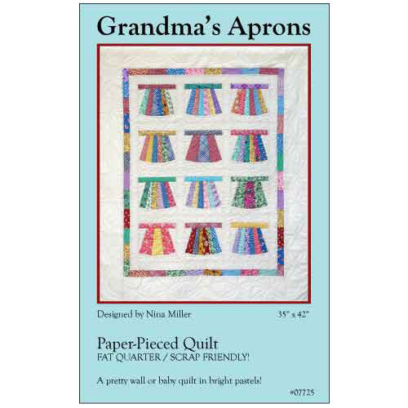
Grandma’s Aprons Instructions
This block is mostly paper-pieced. Please use a variety of 30’s reproduction or vintage fabrics with white or cream tone on tone for the background fabric. If you want, the blocks can be embellished with rick-rack, buttons or lace to add detail-but is not necessary.

General Paper-piecing instructions
Paper-piece the apron skirt, starting with position #1 and going through #6, working outward. Make sure all fabric pieces cover the seam allowances before sewing.

Reduce stitch length on your sewing machine to 18 –20 stitches per inch (about 1.5). This will perforate the paper and make it easier to remove when the time comes.

With printed side of pattern up, FOLD each solid line on the pattern. These are your stitching lines. Fold all the way to the edges

Place fabric for segment #1 right side up on the BLANK side of the pattern, making sure to allow a generous (up to 1/2") seam allowance on all sides of the first segment. Hold it up to a light source to check.

Pin, use double-sided tape or lightly glue-baste fabric to the pattern.

Block Construction:
Apron Skirts
A copy of the apron pattern has been provided for foundation paper-piecing.
The apron can be made as a three-gore, five-gore, or six-gore skirt.

Three-gore skirt
Choose two pieces of apron fabric
Cut two 3” x 6” rectangles from one (the outside gores)
Cut one 3” x 6” rectangle from the other (the center gore)

Five-gore skirt
Chose five pieces or three pieces of apron fabric
Cut four pieces 2” x 6” (can be four different fabrics or two different fabrics-two for left outside and two for right outside)
Cut one piece 3” x 6” (center gore)

Six-gore skirt
Chose six pieces of apron fabric (can be a variety of six different fabrics)
Cut a 2” X 6” rectangle from each fabric

Paper piece the apron skirt using the lines on the template as your seam lines.
Three-gore skirt, the gores numbered 1 and 2 will combine as the center; 3 and 5 will be the left side; and 4 and 6 the right side.
Five-gore skirt, the gores numbered 1 and 2 will combine as the center; then starting with #3 and going through #6, working outward.
Six-gore skirt, starting with position #1 and going through #6, working outward.
Make sure all fabric pieces cover the seam allowances before sewing.
Press toward seam.

Block sides
Cut one 3” x 6” rectangles of background fabric (white or cream tone on tone). Cut in half diagonally from the upper right corner to the lower left corner. (if it is a directional print, cut 2 and cut each piece diagonally in opposite directions).
Press toward seam.

Optional Embellishments
If desired, add rick-rack or lace embellishments to your apron skirts now, before piecing the rest of the block. Buttons should be added either after the block is completed or after quilting.

Waistband
Cut a 7” x 2” waistband strips from your main fabrics
Sew a waistband to the top of each apron block in position #9.
Press toward seam.
Trim the lower edge of the apron skirt along the curved line of the foundation paper.
Remove foundation paper if desired.

Block Bottom
Cut the bottom template from the apron template.
Cut one bottom piece out of the background fabric for each block, using the template provided.
Fold the bottom piece in half and press a crease in the center of the top edge. Match this crease to the center seam at the bottom of the apron skirt. Starting at the center (with the bottom piece on top), pin out to the edges.
Gently ease the curve of the bottom piece to fit the skirt as you sew, with the apron skirt next to the feed dogs of your sewing machine and the bottom piece on top facing the needle.
Press toward seam.

Paper-piecing Tutorial:
https://www.quiltscapesqs.com/search?q=paper+piecing

